### 

### **CAN Bus System for Cruise Control**

### 1. Anupam

### 2. Asha

### 3. Harshvardhan

### 4. Hrushikesh

### 5. Manish

### 6. Krishna

### 7. Tahir

### 

### **Version: 1.7**

### **Created: 05/29/2024**

### **Last Updated: 05/28/2024**

### **Status: Complet****e**

### **CAN Bus System for Cruise Control**

#### **Diagram:**

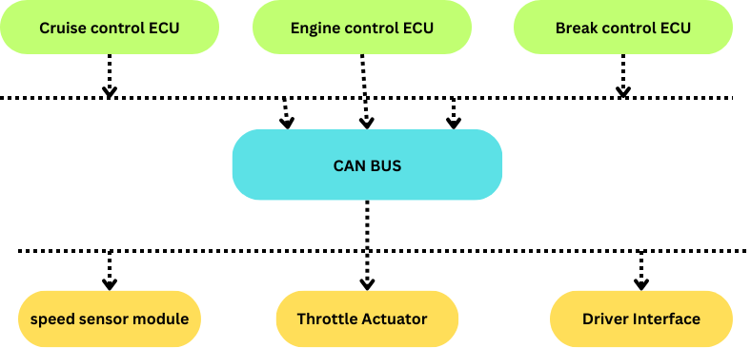

**Explanation**:

**Cruise Control ECU**: This Electronic Control Unit is responsible for managing the cruise control system. It processes inputs from the Driver Interface and the Speed Sensor Module, and sends commands to the Throttle Actuator and possibly the Brake Control ECU to maintain the desired speed.

**Engine Control ECU**: This ECU manages the engine's performance, including throttle control. It receives commands from the Cruise Control ECU to adjust the throttle as needed to maintain the set speed.

**Brake Control ECU**: This ECU manages the braking system. In the context of cruise control, it can receive commands from the Cruise Control ECU to decelerate the vehicle when necessary (e.g., when an obstacle is detected).

**Speed Sensor Module**: This module measures the current speed of the vehicle and sends this information to the Cruise Control ECU via the CAN bus.

**Throttle Actuator**: This actuator adjusts the throttle position based on commands from the Engine Control ECU to control the vehicle's speed.

Throttle Actuator: This actuator adjusts the throttle position based on commands from the Engine Control ECU to control the vehicle's speed

**Driver Interface (Control Switches)**: This interface allows the driver to interact with the cruise control system. It typically includes buttons to set the desired speed, resume, or cancel the cruise control.

#### **CAN Bus:**

* **CAN Bus**: The CAN bus is the communication backbone that connects all the ECUs and modules. It allows for real-time data exchange between different components, ensuring that the Cruise Control system operates smoothly. The CAN bus uses a differential signalling method, making it robust against electrical noise and suitable for automotive environments.

### **Key Functions of the CAN Bus in this System:**

1. **Communication**: Facilitates communication between ECUs and sensors/actuators.
2. **Data Integrity**: Ensures data is transmitted accurately and reliably.
3. **Error Handling**: Provides mechanisms for detecting and correcting errors.
4. **Scalability**: Allows for easy addition of new modules or ECUs without major changes to the system architecture.

This diagram and explanation should give a clear understanding of how a CAN bus system is utilized in an automotive feature like Cruise Control.

.

THANK YOU